PostgreSQL installation (8.4.4-1)
Install Postgresql-8.4.4-1-windows.
Click Next
Leave the proposed path as is, click Next
Leave the proposed data directory as is, click Next
For the postgres superuser account fill in as password ‘postgres’ and click Next
Leave the default port on 5432 and click Next
Click Next
Click Next
When the installation is finished we see
Deselect ‘Launch Stack Builder at exit?’ and click Finish
Postgresql ODBC driver
Install ebd_psqlodbc
Click Next
Leave the proposed path as is and click Next
Click Next, when the installation is finished we see
Click Finish

Postgresql configuration
Go to the directory C:\Program Files\PostgreSQL\8.4\data
Edit the file pg_hba.conf and the end you’ll see
# TYPE DATABASE USER CIDR-ADDRESS METHOD
# IPv4 local connections:
host all all 127.0.0.1/32 md5
# IPv6 local connections:
host all all ::1/128 md5

Change both ‘md5’ to ‘trust’ as below

# TYPE DATABASE USER CIDR-ADDRESS METHOD
# IPv4 local connections:
host all all 127.0.0.1/32 trust
# IPv6 local connections:
host all all ::1/128 trust

Do not forget to save the file
Edit the file postgresql.conf
Remove the hash ‘#’ on the line that contains
#track_counts = on
Remove the hash ‘#’ on the line that contains
#autovacuum = on
Save the file. This change makes sure the dabase is automatically vacuumed.
Under programs/PosgreSQL 8.4 start pgAdminIII.
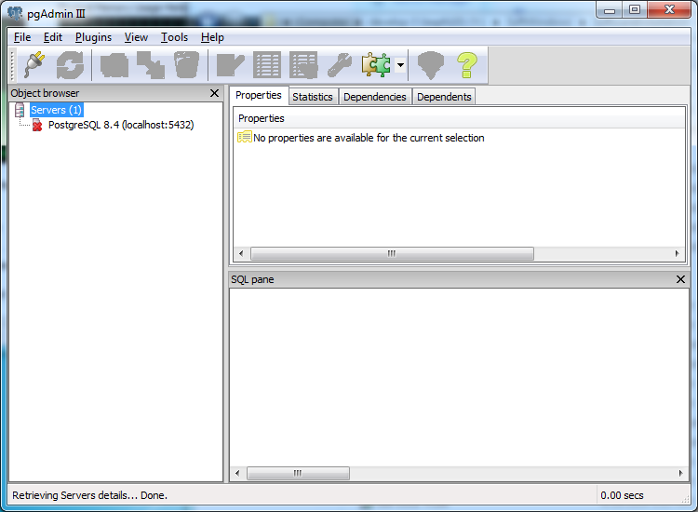
Double click on ‘PostgreSQL 8.4 (localhost:5432), the following window will appear
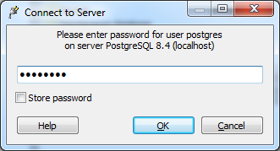
Fill in the password ‘postgres’ and click OK
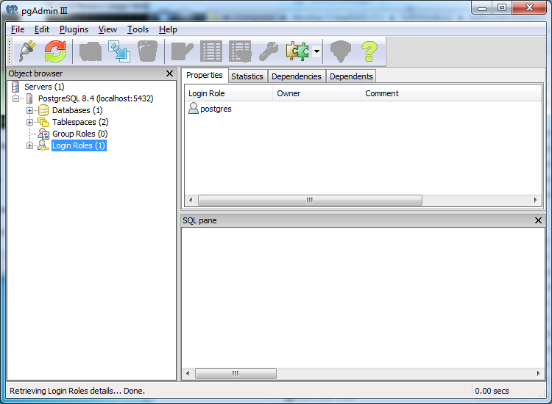
Right click on ‘Login Roles’ and select New Login role…
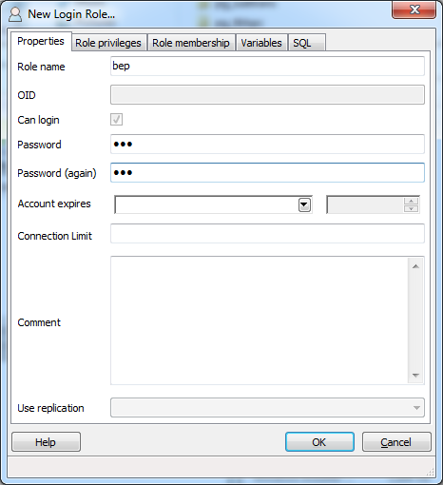
Fill in ‘bep’ as Role name, take as password ‘bep’. Click on the tab ‘Role privileges’
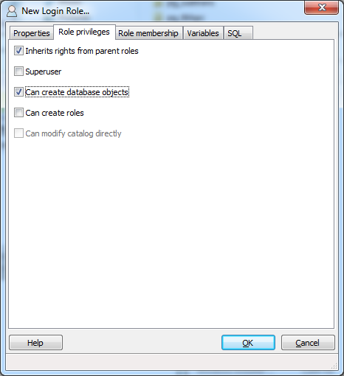
Select ‘Can create database objects’, then click on OK
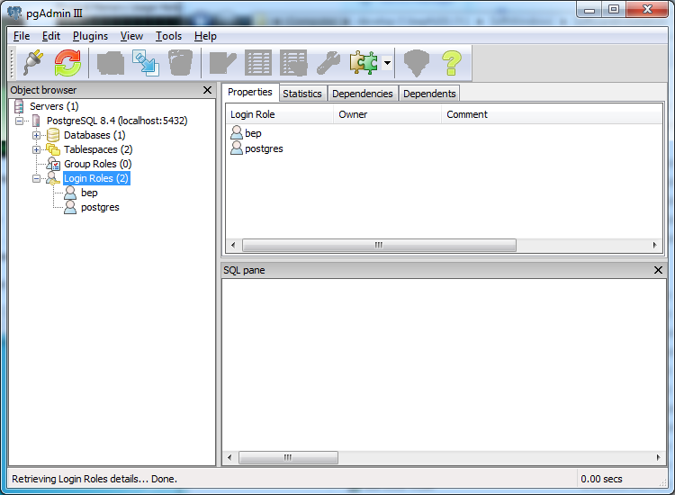
If you open the login roles (click on +) you should see the newly added database user bep. Now right click on databases and select New database…
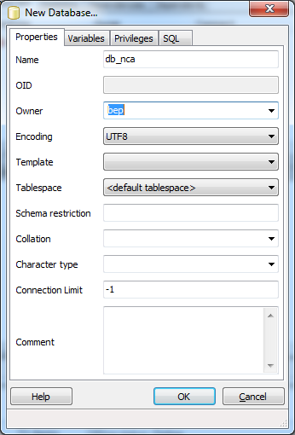
Fill in the name e.g. ‘db_nca’ and select ‘bep’ as the Owner. The encoding should be selected as UTF8. Click on OK. Repeat this step for adding all other necessary databases. At the end we can have the following databases
- db_nca
- db_nca_config
- db_nca_results
- db_hla
- db_hla_config
- db_hla_results
At the end you can verify if you have created all databases correctly (click on + next to Databases). Also verify that the owner of all the databases (except for postgres database) is ‘bep’
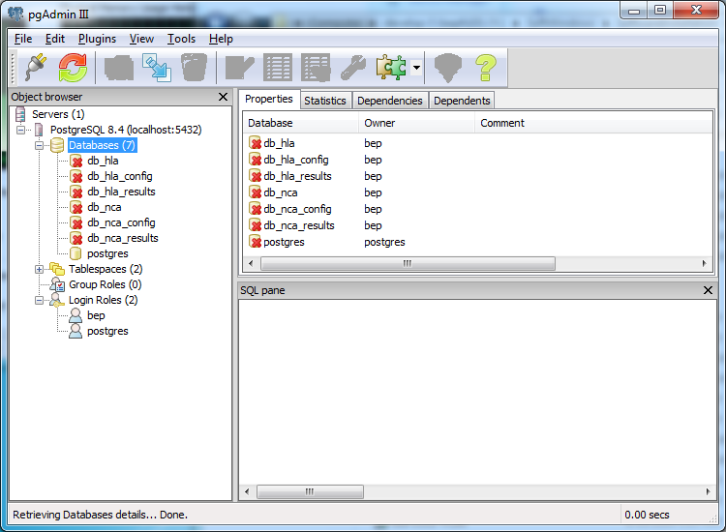

Restoring the databases
Open a cmd prompt, go to the directory where the database dump files are located. For each dump execute the following command
psql –f <dumpfile_name> <db_name>
Where dumpfile_name if the file name of the ‘database dump’ and db_name corresponds with one of the defined databases in the section ‘postgresql configuration’.
After a restore you can verify that all the tables defined in the database also have the correct owner ‘bep’. Verify this by clicking on a specific table and check the owner in the right pane
You can find example database dumps under dbdumpexamples directory.
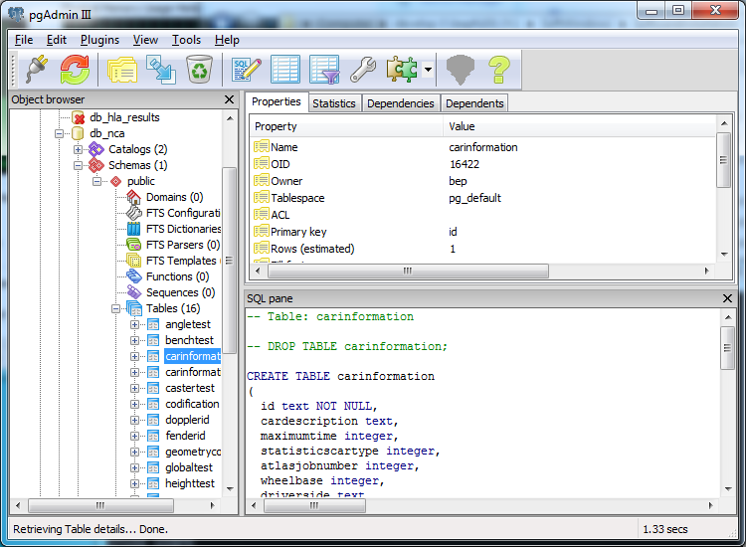

Making a manual dump of a database
Open a cmd prompt. Issue the following command in a directory where you have write access
pg_dump –O –x <db_name> > <dumpfile_name>
The dumpfile will be created in the directory where you executed the command

Defining the ODBC connections
Open ODBC Data sources (ControlPanel/System/Administrative tools). Select tab ‘System DSN’
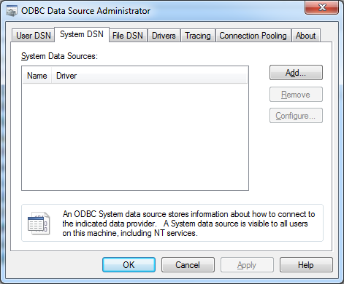
Click on the Add button
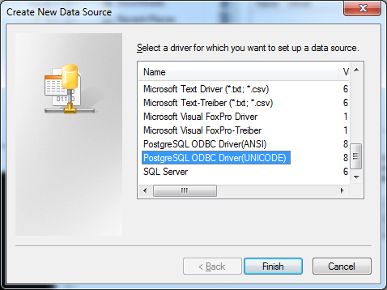
Select the driver PostgreSQL ODBC Driver (UNICODE) and click on Finish.
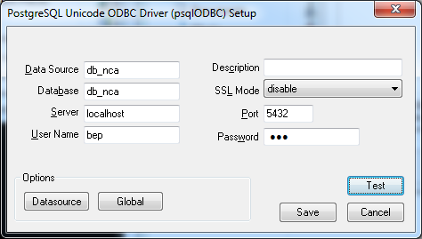
Fill in the data as follows
- Data source (name of the ODBC connection) : ‘db_nca’
- Database (name of the PostgreSQL dabase) : ‘db_nca’
- Server : ‘localhost’
- User Name : ‘bep’
- Password : ‘bep’
Click on the Test button to check that the connection works. If It’s ok click on the Save button. Repeat those steps for all the created databases (db_nca, db_nca_config, db_nca_results, db_hla, db_hla_config, db_hla_results). When a connection is saved it will appear in the list of System DSN ODBC conections.
