MS ACCESS SCREENSHOT

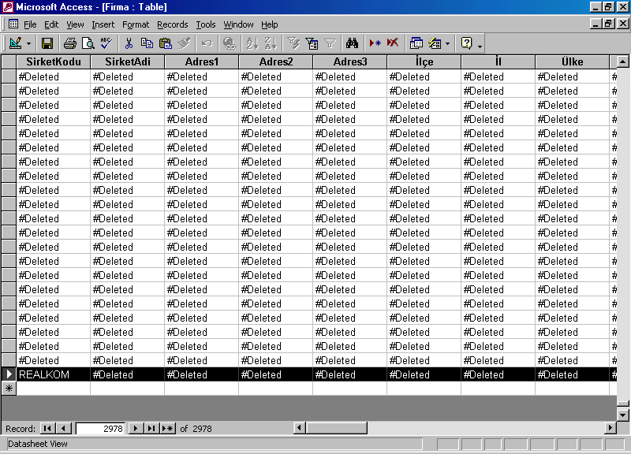

PGADMIN SCREEONSHOT
